Uplink User Manual V1.1

Eric Wang

eric.wang@jcu.edu.au

James Cook University

16/01/2020

|  |  |
| --- | --- |
| Version | Changelogs |
| 1.1 | Add configuration of the calculation using either default pump flow rate or default valve flow rate. |
|  |  |

The Uplink program is designed to create a connection between WiSA and IrrigWeb and aims to extract the irrigation and rainfall data from Aqualink to IrrigWeb. The basic workflow of Uplink is 1) Extract pump, valve and flow meter data from the Aqualink database for the selected timeframe; 2) Based on the valve operation data, e.g., how many valves are operating at what time and for how long; 3) Take the flow meter readings and assign each opened valve with right amount of water flow under different operating status; 4) Calculate the amount of water applied for each valve during the selected timeframe; and 5) Save and upload the irrigation data to the IrrigWeb FTP server.

# Prerequisites

## .Net Framework

The Uplink program only works for the Windows operating system. Microsoft .net framework is required to run the Uplink program. Please download and install the Microsoft .net framework from the link below:

<https://dotnet.microsoft.com/download/dotnet-framework/net48>

## Aqualink

The uplink program relies on the Aqualink database to obtain irrigation and rainfall data. The device properties used by Uplink program are Hydraulic group, Device UID, Device Type, Name, Flow rate, Land Area, as highlighted in the figure below.

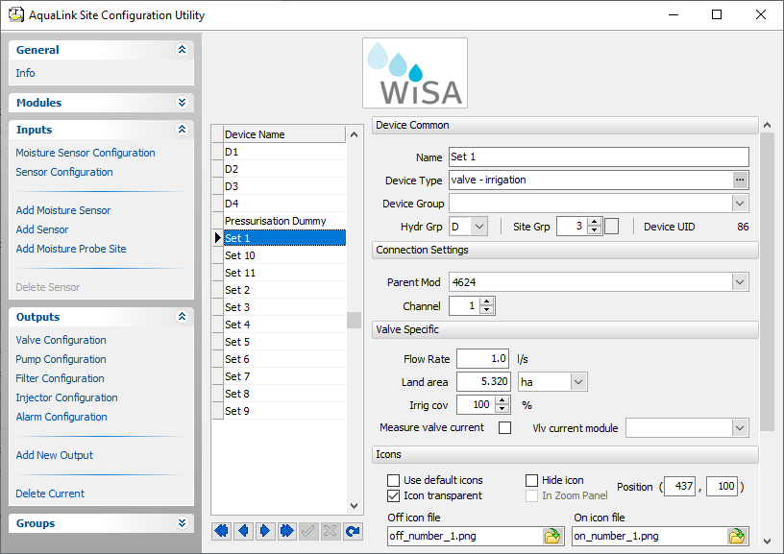

# Installation

The current version of the Uplink program is Uplink V1.0. Please download the latest version of the Uplink program from

<https://www.dropbox.com/sh/7w6ynd07xoqwva6/AAAjc8TF6b-aAA59yrMS1chVa?dl=0>

Please make sure you have download and extract all the files from the link, as shown in the figure below.

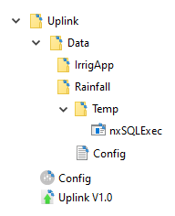

# Software update

The Config program for the Uplink program will automatically check the latest version and notify you to update the program.

# Uplink configuration

The uplink program has to be configured via the Uplink Configuration program before the operation. Please use “Config.exe” to configure and run the Uplink program, as shown in the figure below.

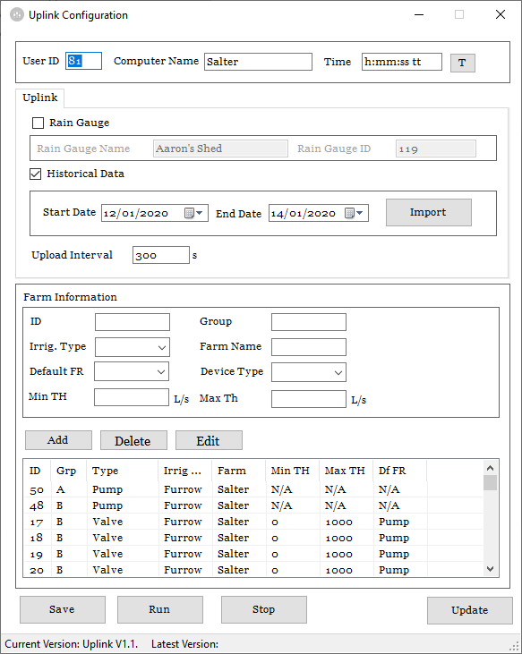

1. User ID: this is a unique IrrigWeb identifier for each farmer;
2. Computer name: please input a unique name that is different from the farm’s name (do not include any symbols in the name);
3. Time format: this is critical to calculate the water volume for each irrigation event. Please make sure it is configured correctly. Click the “T” button to automatically set up time format the first time you run the configuration program. Please refer to the table below for the time format;

|  |  |
| --- | --- |
| "h" | The hour, using a 12-hour clock from 1 to 12. |
| "hh" | The hour, using a 12-hour clock from 01 to 12. |
| "H" | The hour, using a 24-hour clock from 0 to 23. |
| "HH" | The hour, using a 24-hour clock from 00 to 23. |
| "m" | The minute, from 0 through 59. |
| "mm" | The minute, from 00 through 59. |
| "s" | The second, from 0 through 59. |
| "ss" | The second, from 00 through 59. |
| "tt" | The AM/PM designator. |

1. Rain gauge: tick the checkbox if the farm has a rain gauge, and set the rain gauge UID and name;
2. Historical data import: this function is to import historical data, choose the start and finish time and click the import button to import historical data, the result will be automatically opened and uploaded to the FTP server named 21~xxxxhis.dat;
3. Update interval: Uplink upload interval in seconds;
4. Farm information:
   1. ID: is the device UID;
   2. Group: is the group ID, e.g., A, B, C, D;
   3. Irrig. Type: is Drip or Furrow irrigation;
   4. Farm name: is different from the computer name, in case there are multiple farms running on the same computer;
   5. Device Type: choose from Pump, flow meter and valve;
   6. Min. and Max. Threshold: this is to set the flow meter abnormal alarm. If flow meter readings are outside of the range, the Uplink program will trigger an email alert;
   7. Default FR: Default flow rate for calculation, choose between default pump flow or default valve flow;
   8. Add button: is used to add a device;
   9. Double click a row in the table to edit the device and click the Edit button when finishing edit;
   10. Delete button: is used to delete an existing device from the table;
5. The Save button is used to save the configuration;
6. The Run button is to run Uplink
7. The stop button is to stop Uplink
8. The Update button is used to update the Uplink program

# Uplink workflow

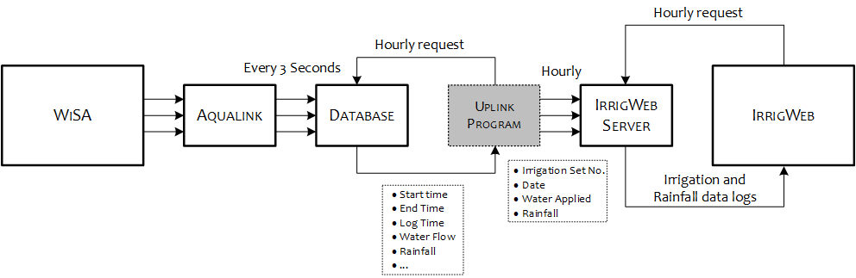

Figure 1 Uplink

The workflow for Uplink is as follows (with the red text representing how Uplink interacts with Aqualink, the green text representing how Uplink processes the data from Aqualink, and the blue text resenting how Uplink interacts with IrrigWeb):

1. Read a configuration file, with the information including the number of hydraulic groups, and information for each hydraulic group, including irrigation type, pump, flow meter and valve IDs.
2. Use “*nxSQLExec*” to query Aqualink database “*ALConfig/Devices*” to obtain the information for each valve, including valve name (*DeviceN*), group ID (*HydGrp*), area (*LandArea*), design flow rate (*MinFlowRate/MaxFlowRate*), etc.
3. Use flow meter and valve IDs (*UID*) to query Aqualink database “*ALData/Outputlogs and ALData/SensorLogs*” to obtain the data within the query time frame (e.g., 01/04/2018 – 07/04/2018) for each hydraulic group, including the log time (*LogDT*) and log value (*SValue*) of the flow meter, and the start time (*StartDT*) and end time (*FinishDT*) of the valves.
4. Calculate the individual flow rate for each irrigation set at each log time:
   1. For drip sets, $f_{i}=f_{M}\frac{fs_{i}}{\sum_{i}{fs_{i}}}$ (litre/second), where $f_{i}$ is the individual flow rate for valve $i$, ${fs}_{i}$ is the design flow rate of valve $i$, $f_{M}$ is the flow rate of flow meter at this log time, and $\sum_{i}{fs_{i}}$ is the sum of the design flow rate of all the valves that are opened at this log time.
   2. For furrow sets, $f_{i}=f_{M}\frac{A_{i}}{\sum_{i}{A_{i}}}$ (litre/second), where $A_{i}$ (ha) is the area of the irrigation set $i$.
5. Calculate the irrigation water amount for each set,
   1. For the hydraulic group with a flow meter, $W_{i}=\sum_{t_{s}<t<t_{e}}{{(f}_{i_{t}}×I_{t}})$ (litre), where $W_{i}$ is the water amount, $f_{i_{t}}$ is the flow rate for valve $i$ at time $t$ between the start time $t_{s}$ and end time $t_{e}$, and $I_{t}$ is the time interval for each flow rate log (e.g., 300 seconds or 180 seconds).
   2. For the hydraulic group without a flow meter, $W_{i}=\sum_{t_{s}<t<t_{e}}{{(fs}_{i}×I_{t}})$ (litre).
6. Calculate the water applied, ${wa}_{i}=\frac{W_{i}}{A_{i}×10000}$ (mm).
7. The water applied for each irrigation set during the last 7-day is calculated and saved into a file named “*Famer ID*~*Farm name*.dat”, with the following format:

*Name,Date,Block,Water Applied (mm)*

*Home,05/02/2018,D2,6.91*

*Home,05/02/2018,D1,6.91*

*Home,05/02/2018,D3,5.31*

*Home,05/02/2018,D4,5.31*

*Home,05/02/2018,D5,0.00*

*Home,04/02/2018,D2,12.68*

*Home,04/02/2018,D1,12.68*

*Home,04/02/2018,D3,13.54*

*Home,04/02/2018,D4,13.54*

*Home,04/02/2018,D5,0.00*

*Home,03/02/2018,D2,16.70*

*Home,03/02/2018,D1,16.70*

*Home,03/02/2018,D3,13.82*

*Home,03/02/2018,D4,13.82*

*Home,03/02/2018,D5,0.00*

1. The file is uploaded to IrrigWeb FTP server folder “*/IrrgApp*”.
2. IrrigWeb server interrogates the FTP folder every hour and updates the irrigation data for each farmer.

# Water applied calculation

The amount of water applied to each irrigation block can be calculated as *the recorded flow rate on the valve flow meter multiplied by the recording interval then multiplied by the number of records.* Since in the test farm, there are no flow meters at each valve, the flow rate for each valve can be approximated to be proportional to the area.

Mathematically, we can generalise the calculation of the amount of water applied and develop an algorithm to implement this calculation in the Uplink program. Let $T_{i,n}∈\{T_{i,1},T_{i,2},…,T_{i,N}|i∈\left\{1,I\right\}, n∈\left\{1,N\right\}\}$ and $F_{i,n}∈\{F_{i,1},F_{i,2},…,F_{i,N}|i∈\left\{1,I\right\}, n∈\left\{1,N\right\}\}$ be the timestamp and flow rate for the nth record of flow meter $i$, where $I$ is the total number of flow meters in the hydraulic group, and $N$ is the total number of records for flow meter $i$. Defined by $T_{j,m}^{S}∈\{T_{j,1}^{S},T_{j,2}^{S},…,T_{j,M}^{S}|j∈\left\{1,J\right\}, m∈\left\{1,M\right\}\}$ and $T_{j,m}^{F}∈\{T_{j,1}^{F},T_{j,2}^{F},…,T_{j,M}^{F}|j∈\left\{1,J\right\}, m∈\left\{1,M\right\}\}$ the start time and finish time for the mth irrigation event of valve $j$ in one day, where $J$ is the total number of irrigation blocks, and $M$ is the total number of irrigation events for valve $j$. Here, the normalised flow rate for record ${\tilde{F}}_{i,n}$ is defined as the recorded flow rate divided by the sum of areas $A_{j}$ of irrigation blocks $j$ opened at this timestamp, represented as follows:

${\tilde{F}}_{i,n}=\frac{F_{i,n}}{\sum_{j∈J_{O}}{A_{j}}} (litre/second/ha), { J}_{O}=\{j|T_{j,m}^{S}<T_{i,n}< T_{j,m}^{F}\}$

The total amount of water applied (litre) in one irrigation event $W_{j,m}$ for an irrigation block can be calculated as the summation of the normalised recorded flow rate which satisfies $T_{i,n}∈\{T_{j,m}^{S},T_{j,m}^{F} \}$ multiplied by the recording interval (which is set to 5 minutes in Aqualink), then multiplied by the area of irrigation block $j$, which can be represented as:

$W_{j,m}=A_{j}\sum_{i=1}^{I}{\left(\sum_{n=1}^{N}{{\tilde{F}}_{i,n}×300 }\right)} (litre)$

while the timestamp $T_{i,n}$ of each normalised flow rate record ${\tilde{F}}_{i,n}$ is within $\left\{T_{j,m}^{S},T_{j,m}^{F}\right\}$. Thus, the total amount of water applied (mm) for irrigation block $j$ in one day can be calculated as:

$W_{j}=\sum_{m}^{M}{\frac{W_{j,m}}{10000A_{j}}} (mm)$

Please refer to the table below for the water applied calculation for different irrigation scenarios.

Table 1 Water applied calculation for different scenarios (litre)

|  |  |  |  |
| --- | --- | --- | --- |
| **Irrigation scenarios** | | **With flow meter** | **Without flow meter** |
| Single pump | Only on valve opened | Actual flow rate * duration | Default flow rate * duration |
| Multiple valve opened | Actual flow rate * duration * (block area/total area) | Default flow rate * duration |
| Multiple pumps | Only on valve opened | Actual total flow rate * duration | Default flow rate * duration |
| Multiple valve opened | Actual total flow rate * duration * (block area/total area) | Default flow rate * duration |

# Uplink Monitor V1.0

The uplink monitor is a management program (needs to be running on the management team’s computer) developed to monitor the operation status of the Uplink program in all the farms. The program will show the last updated time of the Uplink program at the farm and will push a notification or email if the Uplink program has not been updated for more than 24 hours.

The Uplink monitor program can be download from the link below.

<https://www.dropbox.com/sh/k4v5ucti7j12t1s/AABuHh5OIgnn9X1NpI4BjmTNa?dl=0>

The use of this program is straightforward, as shown in the figure below.

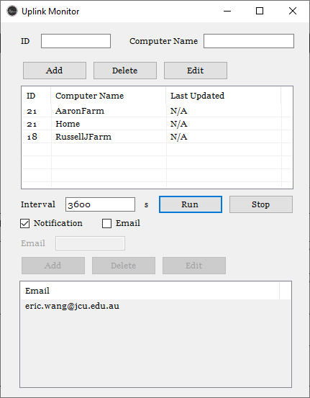

1. ID: the IrrigWeb ID for the farmer;
2. Computer Name: should be identical to the name setup in Uplink;
3. Add, delete and Edit buttons are used to add, delete and edit the farm information on the table;
4. Interval: is to set up how often the Uplink monitor check the Uplink program on each computer;
5. Run and Stop button are used to start and stop the monitor;
6. Tick the notification checkbox to enable notification on the computer;
7. Tick the Email checkbox to enable sending an alert email to all the email addresses in the table below;
8. Add, delete and edit buttons are used to add, delete and edit the email addresses on the table;